Listagem Equipamentos com os IP’s e o gateway IPV4:

| **Lab 1 - IPV4** | | **Lab 2 - IPV4** | | **Lab 3 - IPV4** | |
| --- | --- | --- | --- | --- | --- |
| **PC 0** | 128.137.140.10 | **Laptop 0** | 124.193.252.101 | **PC 4** | 36.236.36.30 |
| **PC 1** | 128.137.140.11 | **Laptop 1** | 124.193.252.102 | **Laptop 4** | 36.236.36.31 |
| **PC 2** | 128.137.140.12 | **Laptop 2** | 124.193.252.103 | **PC 5** | 36.236.36.32 |
| **PC 3** | 128.137.140.11 | **Laptop 3** | 124.193.252.104 | **Laptop 5** | 36.236.36.33 |
| **Gateway** | 128.137.140.1 | **Gateway** | 124.193.252.100 | **Gateway** | 36.236.36.1 |

Ping de envio de pacotes entre os equipamentos:

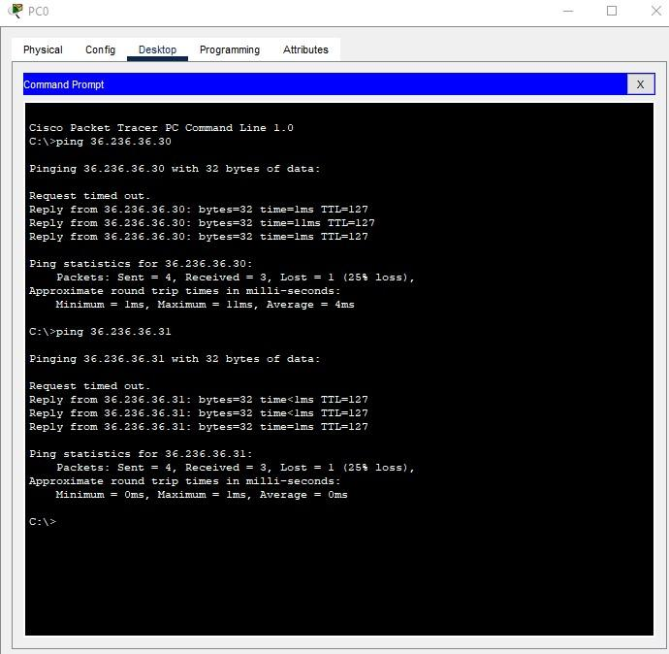

Listagem Equipamentos com os IP’s e o gateway IPV6:

| **Lab 1 - IPV6** | | **Lab 2 - IPV6** | | **Lab 3 - IPV6** | |
| --- | --- | --- | --- | --- | --- |
| **PC 0** | ABCD::20 / 64 | **Laptop 2** | F0CA::10 /64 | **PC 5** | B0CA::30 / 64 |
| **PC 1** | ABCD::21 /64 | **Laptop 1** | F0CA::11 /64 | **PC 6** | B0CA::31 / 64 |
| **PC 2** | ABCD::22 / 64 | **PC 3** | F0CA::12 /64 | **Laptop 3** | B0CA::32 / 64 |
| **Laptop 0** | ABCD::23 /64 | **PC 4** | F0CA::13 /64 | **Laptop 4** | B0CA::33 / 64 |
| **Gateway** | ABCD:: 3000 | **Gateway** | F0CA::3000 | **Gateway** | B0CA::3000 |

Ping de envio de pacotes entre os equipamentos:

